SLA Annual Conference, Boston, June 2015
Ruth Owens, SUNY ESF

Thanks to a professional development grant from CLRC, I was able to travel to Boston, MA, for the Annual Conference of the Special Libraries Association (SLA). I attended several valuable sessions on topics such as laboratory safety information literacy, chemistry resources, 3D printing, and information literacy frameworks.

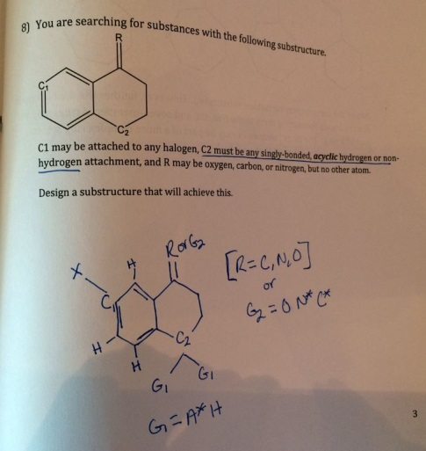
I completed a continuing education course at the conference on chemical information sources, requests, and reference, and it was certainly a highlight. Throughout the course, reference scenarios were presented and we had to discuss in groups how we might answer the questions. The latter portion of the course was actually quite fun as we practiced drawing chemical substructures and designing searches using those drawings. I was surprised at how much I remembered from my organic chemistry course as an undergraduate! This course helped me better understand how to search chemistry related databases, and I plan to utilize several of the resources discussed as I assist faculty and students at my institution.

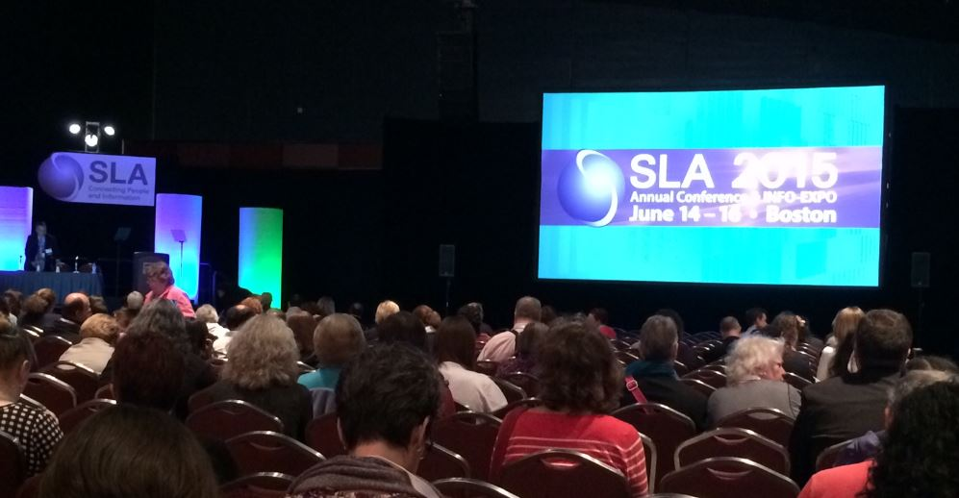
Another highlight was making connections with many wonderful information professionals from around the world who work in academic, government, and corporate libraries. Currently, I am the treasurer for Upstate New York Chapter of SLA, and it was great to meet other chapter and division treasurers and talk with leaders within the association.

One take away I have from this conference is to take initiative and be active professionally. The theme of the conference was “Be Revolutionary,” and I came away feeling empowered to demonstrate the value of the library to my institution as well as the librarianship profession.

I did have a little time to explore Boston and made sure to see the Make Way for Ducklings sculpture in the Boston Public Garden. If you’d like to know more about my experience at the SLA conference or about SLA, please contact me at rmowens@esf.edu.
